Project Title

Book Store Management System

Guided By:

Trainer Name:- Anuj Kumar

Created By:-
Student Name | AFid
Anshul Anand Pandey | AF04991875
Anupam Chaturvedi | AF04991837
Pratyush Singh | AF04992108

Batch Code:- ANP-D2405

Course Code:- ITPR

- Introduction
A Book Store Management System is a software application designed to automate the operations of a bookstore. Traditional bookshops often depend on manual processes for managing inventory, sales, billing, and customer information—leading to errors, delays, and inefficiency.
This project aims to develop a computerized system that simplifies book record-keeping, improves accuracy, and enhances customer service.

- Objectives
- The main objectives of the system are:
- To digitize and automate daily operations of a bookstore.
- To maintain accurate records of books, categories, stock levels, and suppliers.
- To provide quick search options for books based on title, author, ISBN, or category.
- To handle customer billing and generate invoices.
- To keep track of sales, purchases, and inventory updates.
- To reduce workload and improve productivity.

Project Category
Application Development using Java & MySQL

Problem in Existing System
- The current manual system involves:
- Physical registers for stock and sales.
- Manual invoice generation.
- Difficulty in tracking stock and frequently sold books.
- High chances of human error.
- Time-consuming data retrieval.
This leads to inefficiency, mismanagement, and customer dissatisfaction.

Proposed System
The proposed computerized system offers:
- Centralized database for books, customers, and sales.
- Automated billing and inventory updates.
- Quick search and filter options.
- User authentication (Admin/Staff).
- Low maintenance cost.
- Easy generation of reports—daily, weekly, monthly.

Modules Description

1. Admin Module
The Admin Module is the central control system of the bookstore management application. It provides administrative users with full access to manage core functionalities, users, and system configurations.

Key Features:

a. Manage Users (Add/Edit/Delete Staff)
- Allows the administrator to create new user accounts for staff.
- Staff roles can be assigned (e.g., Cashier, Sales Staff, Manager).
- Admin can modify user details such as username, password, and access roles.
- Inactive or unauthorized staff can be removed or disabled.
- Ensures secure login and activity tracking.

b. Manage Categories and Suppliers
- Admin can create and maintain book categories such as Fiction, Science, Technology, Kids, etc.
- Supplier details—name, contact, address—can be added and updated.
- Categories help in organizing books across the system.
- Supplier management supports better coordination for restocking.

c. Generate Reports
- Admin can generate different types of business reports.
- Reports include sales performance, stock summary, best-selling books, etc.
- Reports can be exported (PDF/Excel) depending on system implementation.
- Helps in decision-making and business analysis.

2. Book Management Module
The Book Management Module is responsible for maintaining the complete catalog of books in the inventory. It helps keep stock information updated and organized.

Key Features:

a. Add / Update / Delete Books
- Enter book details such as title, author, category, ISBN, price, publisher.
- Update book information when price or availability changes.
- Remove discontinued or outdated books from inventory.

b. Track Stock Levels
- Shows real-time stock quantities for each book.
- Automatically reduces stock after a sale is completed.
- Helps avoid overstocking or understocking.

c. Manage Book Categories and Authors
- Admin or staff can assign books to appropriate categories.
- Author information can be added and linked to books.
- Helps with advanced search and filtering of books for both staff and customers.

3. Sales/Billing Module
The Sales/Billing module handles customer transactions, bill generation, and stock adjustments.

Key Features:

a. Create Invoices
- Staff can add selected books to the billing cart.
- Automatically calculates book price, tax, quantity, and final total.
- Generates invoice/bill which can be printed or saved digitally.

b. Update Stock Automatically After Sales
- Each sale reduces the corresponding book’s stock count.
- Prevents manual errors in stock management.
- Alerts are generated when stock reaches low levels.

c. Apply Discounts
- Allows staff to apply percentage-based or amount-based discounts.
- Supports seasonal/ festival/ promotional discounts.
- Discount details appear on the invoice.

4. Customer Module
The Customer Management module stores and manages customer-related data for billing and marketing purposes.

Key Features:

a. Store Customer Information
- Stores customer details like name, phone, email, address.
- Used during billing or for returning customers.
- Useful for customer loyalty programs or personalized recommendations.

b. View Purchase History
- Shows all previous purchases of a customer.
- Helps in handling returns, complaints, or re-orders.
- Supports customer behavior analysis and targeted promotions.

5. Reports Module
This module provides detailed analytical reports for ensuring smooth business operations and growth insights.

Key Features:

a. Sales Report
- Displays daily, weekly, monthly, or yearly sales trends.
- Helps identify peak sales season.
- Shows total revenue, number of invoices, and top-performing staff.

b. Stock Report
- Shows current stock levels for all books.
- Highlights books that need replenishment.
- Helps manage inventory efficiently.

c. Fast-Moving Books
- Identifies books with high demand and rapid sales.
- Helps prioritize reordering and supplier negotiations.
- Useful for planning promotions or stocking popular titles.

d. Low-Stock Alerts
- Generates alerts when stock falls below a set threshold.
- Ensures timely restocking.
- Prevents the loss of sales due to unavailable books.

Database Design (8 Tables)

1. USERS TABLE
Column | Type | Constraints | Description
user_id | INT | PK, AUTO_INCREMENT | Unique User ID
username | VARCHAR(100) | NOT NULL, UNIQUE | Login Username
password | VARCHAR(255) | NOT NULL | Encrypted Password
role | ENUM('Admin','Staff') | NOT NULL | User Role

2. CATEGORY TABLE
Column | Type | Constraints
category_id | VARCHAR(100) | PK, AUTO_INCREMENT
category_name | VARCHAR(150) | NOT NULL

3. AUTHOR TABLE
Column | Type | Constraints
author_id | VARCHAR(100) | PK, AUTO_INCREMENT
author_name | VARCHAR(200) | NOT NULL

4. SUPPLIER TABLE
Column | Type | Constraints
supplier_id | INT | PK, AUTO_INCREMENT
supplier_name | VARCHAR(200) | NOT NULL
contact | VARCHAR(20) | NULL
email | VARCHAR(150) | NULL

5. BOOK TABLE
Column | Type | Constraints
book_id | VARCHAR(100) | PK, AUTO_INCREMENT
title | VARCHAR(300) | NOT NULL
isbn | VARCHAR(30) | UNIQUE
price | DECIMAL(10,2) | NOT NULL
stock_qty | INT | NOT NULL
category_id | VARCHAR(100) | FK → category(category_id)
author_id | VARCHAR(100) | FK → author(author_id)
supplier_id | INT | FK → supplier(supplier_id)

6. CUSTOMER TABLE
Column | Type | Constraints
customer_id | VARCHAR(50) | PK, AUTO_INCREMENT
customer_name | VARCHAR(200) | NOT NULL
phone | VARCHAR(20) | NULL
email | VARCHAR(150) | NULL

7. SALES TABLE
Column | Type | Constraints
invoice_id | INT | PK, AUTO_INCREMENT
customer_id | INT | FK → customer(customer_id)
user_id | INT | FK → users(user_id)
date | DATETIME | NOT NULL
total_amount | DECIMAL(10,2) | NOT NULL

8. SALES_DETAILS TABLE
Column | Type | Constraints
sales_detail_id | INT | PK, AUTO_INCREMENT
invoice_id | INT | FK → sales(invoice_id)
book_id | VARCHAR(100) | FK → book(book_id)
quantity | INT | NOT NULL
price | DECIMAL(10,2) | NOT NULL

ER Diagram Overview
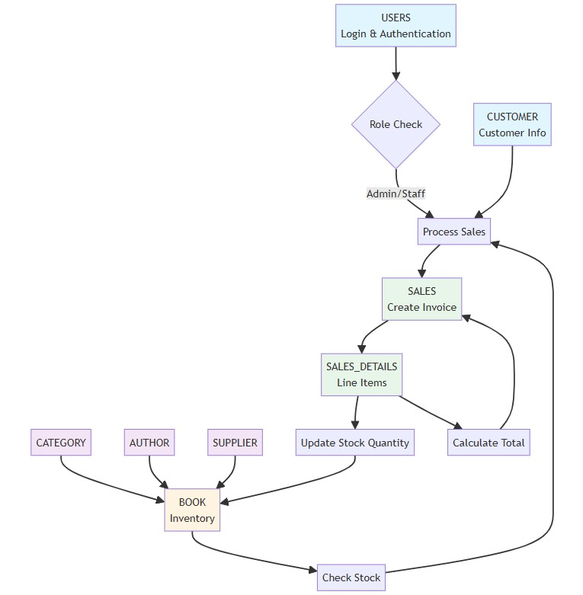

Data Flow Diagram (DFD)

DFD Level 0:
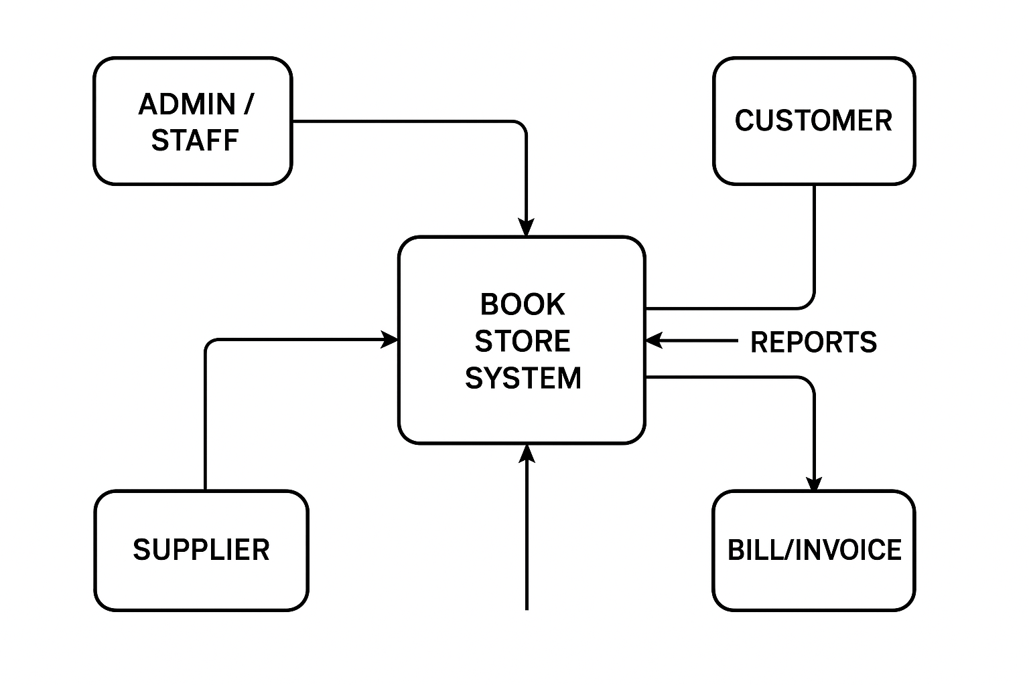

DFD Level 1:
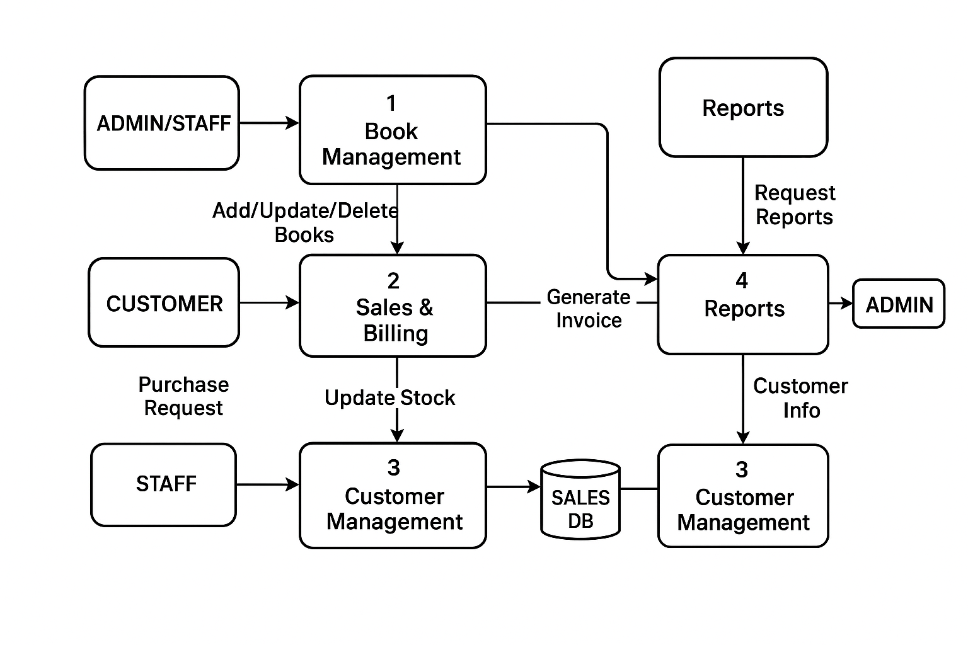

Platform Used

Hardware Requirements
- Intel processor
- 4 GB RAM
- 20 GB free disk space

Software Requirements
- Windows 10/11
- Java JDK (17 or above)
- Eclipse IDE
- MySQL Server & MySQL Workbench
- JDBC Connector JAR
Future Scope
- The system will be used by:
- Bookstore owners
- Store managers
- Staff members (sales/billing)
- Admin/Back-office users
The project is suitable for small and medium bookstores and can later be upgraded to an online store or integrated with e-commerce platforms

